
REPUBLIC OF CAMEROON REPUBLIQUE DU CAMEROUN
************************ **************************
PEACE-WORK-FATHERLAND PAIX-TRAVAIL- PATRIE
*********************** ****************************

Course: C Programming
PKFOKAM INSTITUTE OF EXCELLENCE

PROJECT REPORT
Project Progress Report 1

GIT HUB REPOSITORY AND PERSON
MANAGEMENT CREATION

A
PROJECT
ND
TION
A
WEDDING INVIT
:
Group Members | Participation | Matricules
Matchim Dzuyim Verenne Celia (Group Leader) | 22% | 26S031
Djomo Yepdi Evans | 19% | 26S001
Talla Tchossi Daniella Elsa | 19% | 26S018
Mekolle Tuatsop Dalhia Aure | 21% | 26S004
Messi Zang Paul Jacques | 19% | 26S005

Lecturer:

Mr. Mbietieu Amos Mbietieu

Academic Year: 2025/2026

Table of Content

Project Overview……………………………………………………………………...2

Development Tools Used…………………………………………………………….. 3

Work Organisation and task distribution…………………………………………….. 4

System Architecture………………………………………………………………….. 4

Functional Modules of the Application………………………………………………. 5

5.1 Creating Github respository……………………………………………………….. 6

5.1.1 Adding collaborators…………………………………………………………… 7

5.1.2 Cloning the Respository and first Push…………………………………………. 7

Creation of the of the c program to manage the guest………………………………. 8

Main Difficulties Encountered……………………………………………………….. 10

Solution Implemented………………………………………………………………... 10

Phase 1 Summary……………………………………………………………………...10

References……………………………………………………………………………. 11

Gantt project…………………………………………………………………………. 11

System design………………………………………………………………………… 12

11.1 Class Diagram……………………………………………………………………… 13

11.2 Use Case Diagram………………………………………………………………….. 14

11.3 Sequence Diagram…………………………………………………………………... 15

11.4 Deployment Daigram………………………………………………………………...16

Mnemonic Table…………………………………………………………………….. 16

12.GNU Image Manipulation(GTK) and Comma-Selected Value (CSV)…………………… 17
12.1 GTK…………………………………………………………………………………….17
12.1.1 key Implementation……………………………………………………………….19
12.2 CSV file……………………………………………………………………………….. 21

12.2.1 Problem Encountered………………………………………………………………. 21

Conclusion………………………………………………………………………….. 22

13. Person and Category Management:Implementation and Test……………………………22

13.1 Person management…………………………………………………………………… 22

13.1.1 Extract of Person Management C-code……………………………………………. 22

13.1.2 Extract of person management GTK c-code……………………………………….. 23

13.1.3 GTK successfully…………………………………………………………………… 24

13.1.4 Executable…………………………………………………………………………… 24

13.2 Category Management……………………………………………………………………25

13.2.1 Extract of Category Management C-code…………………………………………….25

13.2.2 Extract Category Management GTK code……………………………………………26

13.2.3 Category ran successfully……………………………………………………………..26

13.2.4 Executable file………………………………………………………………………… 26

13.2.5 Category Manager Window…………………………………………………………... 27

13.2.6 Assignment Page……………………………………………………………………… 27

14. Combination of Person and Category Management onto a Single…………………………… 27

14.1 Main code with c only……………………………………………………………………… 27

14.2 Extract of main code with c…………………………………………………………………. 28

14.3 Mainapp run successfully……..……………………………………………………………. 28

14.4 Executable file……………………………………………………………………………… 28

14.5 Main Window……………………………………………………………………………… 29

15 Conclusion………………………………………………………………………………………29

Project Overview
The Wedding Invitation and Gift Management System (WIGMS) is a software application designed to assist in organizing and managing wedding events. Weddings in Cameroon often involve a large number of guests, gift contributions, and multiple social categories, which makes manual management difficult.
The purpose of this system is to simplify wedding planning by providing tools to manage:
- Guest information
- Social categories of guests
- Invitation priority
- Wedding gift tracking
The application is developed using the C programming language and follows a modular programming approach where each part of the system is implemented as an independent module.
The system aims to improve organization, reduce errors, and help wedding planners efficiently manage guest lists and gifts.

2. Development Tools Used
The following tools were used during the development of the system:
Tool | Purpose
C Programming Language | Main programming language used for system implementation
GCC Compiler | Used to compile and run the C programs
Visual Studio Code / CodeBlocks | Code editor for writing and debugging the program
GitHub | Version control and collaboration platform
Standard C Libraries  (stdio.h, ++ stdlib.h, string.h) | Used for input/output operations, memory management and string handling
These tools help ensure efficient development, collaboration, and proper project management.
3. Work Organisation and task distribution
The group consisted of 5 members. The work organisation depended on assigning responsibilities with respect to skills and the project phases. This approach permitted us to ensure that each section of this report would benefit from dedicated expertise.
Group Member | Main Role | Assigned Tasks
1. Matchim Dzuyim Verenne Celia | Implementation and testing | Common tasks: Project Overview, Development Tools Used, System Architecture, Phase 1 Summary. Individual tasks: GTK, CSV, Test of Person Management, Test of Category Management.
2. Mekolle Tuatsop Dalhia Aure | Documentation and planning | Common tasks: Project Overview, Development Tools Used, System Architecture, Phase 1 Summary. Individual tasks: Report 1, Gantt Project, Report 2, Implementation of Category Management.
3. Talla Tchossi Daniella Elsa | Development (core modules) | Common tasks: Project Overview, Development Tools Used, System Architecture, Phase 1 Summary. Individual tasks: GTK, CSV, Implementation of Person Management.
4. Messi Zang Paul Jacques | System design (UML diagrams) | Common tasks: Project Overview, Development Tools Used, System Architecture, Phase 1 Summary. Individual tasks: Use Case Diagram, Class Diagram.
5. Djomo Yepdi Evans | System modeling and deployment | Common tasks: Project Overview, Development Tools Used, System Architecture, Phase 1 Summary. Individual tasks: Sequence Diagram, Deployment Diagram.

4. System Architecture
The application follows a simplified modular architecture inspired by the MVC design pattern. The architecture consists of three main components:
- Model
The model contains the core data structures and logic of the program, including:
  - Person management
  - Category management
  - Priority management
  - Gift management

- Controller
The controller handles the flow of the application by managing the interactions between the user interface and the program modules.
- View
The view represents the interface presented to the user. In this project, the view is implemented through a console-based menu interface that allows the user to navigate through the different system functionalities.
This architecture ensures clear separation between data, logic, and user interaction.

5. Functional Modules of the Application
As first stage, we did what we consider as our Module 1: GitHub creation + Personal Management. This module focuses on:

3.1 Creating GitHub repository

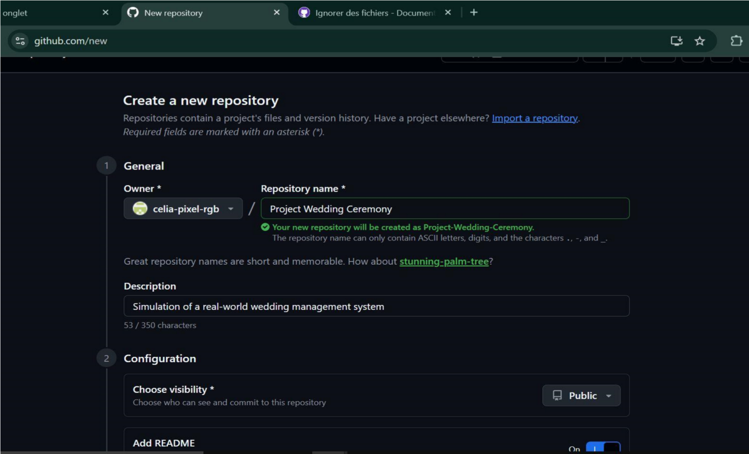
The group leader created the public repository with the following settings:
Here is the GitHub link to access our repository:
https://github.com/celia-pixel-rgb/Project-Wedding-Ceremony

SETTINGS | VALUE CHOSEN
Repository name | Project-Wedding-Ceremony
Visibility | Public
.gitignore | C template selected
Repository link | https://github.com/celia-pixelrgb/Project-Wedding-Ceremony

3.1.1Adding Collaborators
The remaining group members were added as collaborators through the
Setting --» collaborators page of the repository. Each member received an Email invitation from GitHub which they accepted in order to gain push access to the repository.
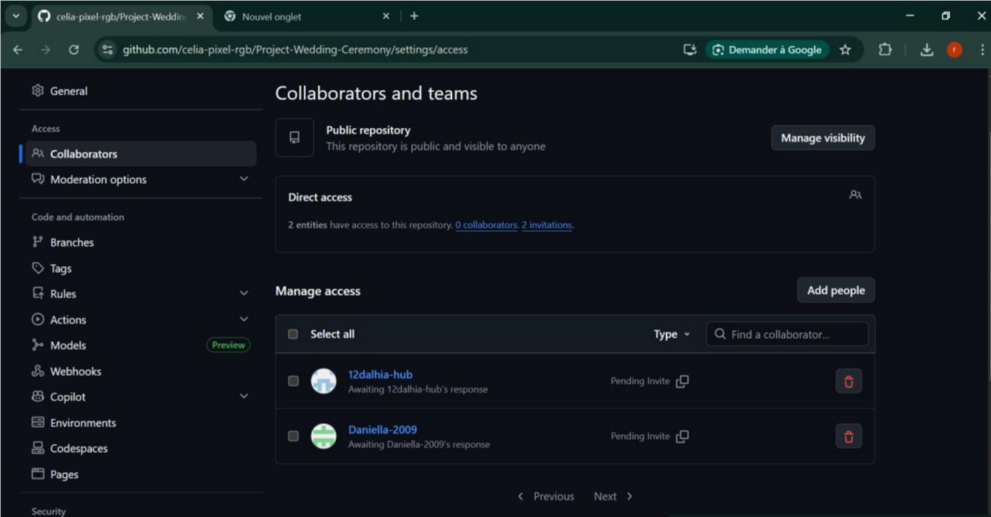

3.1.2Cloning the Repository and first Push
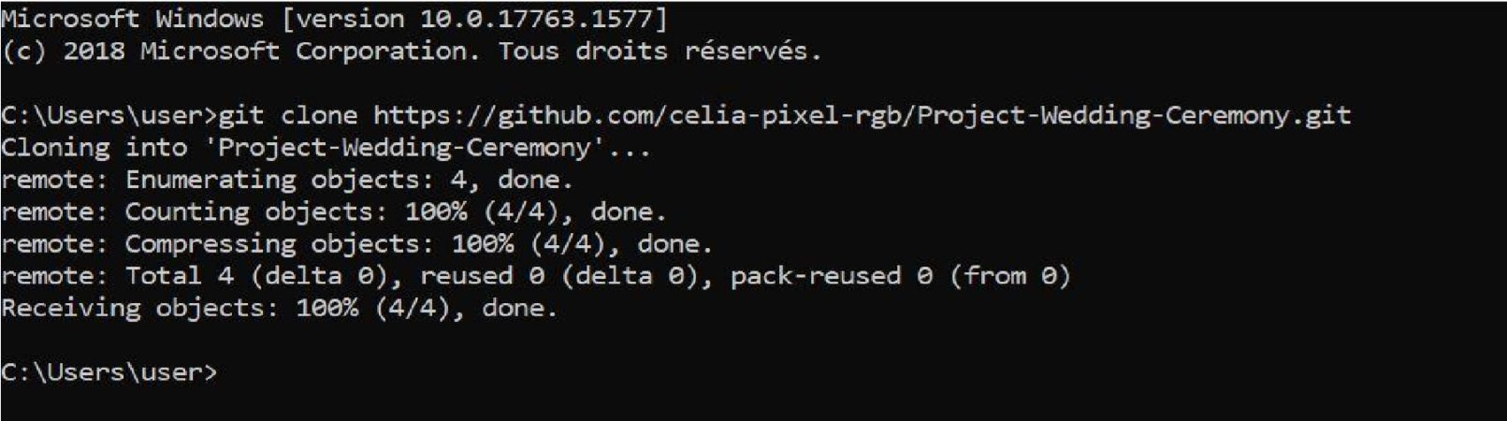
After accepting their invitation, each member cloned the depository into their local machine. The group leader then performed the first push of the program.

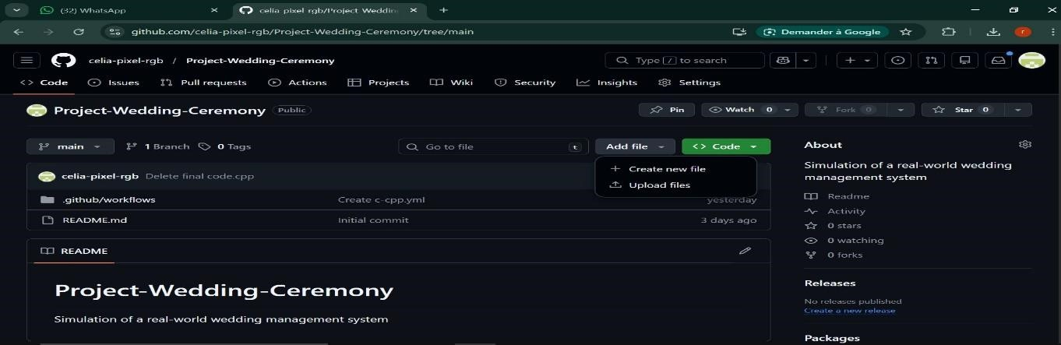
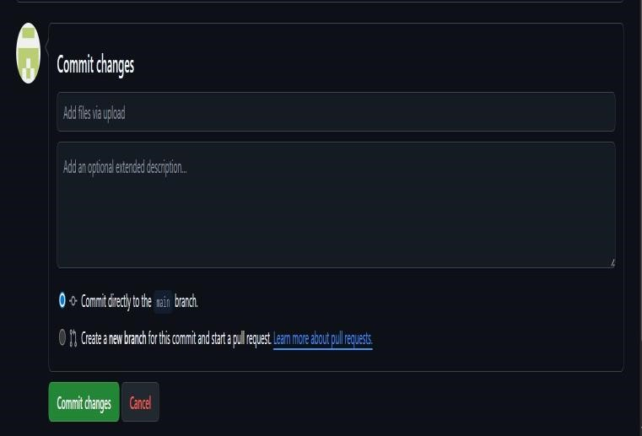
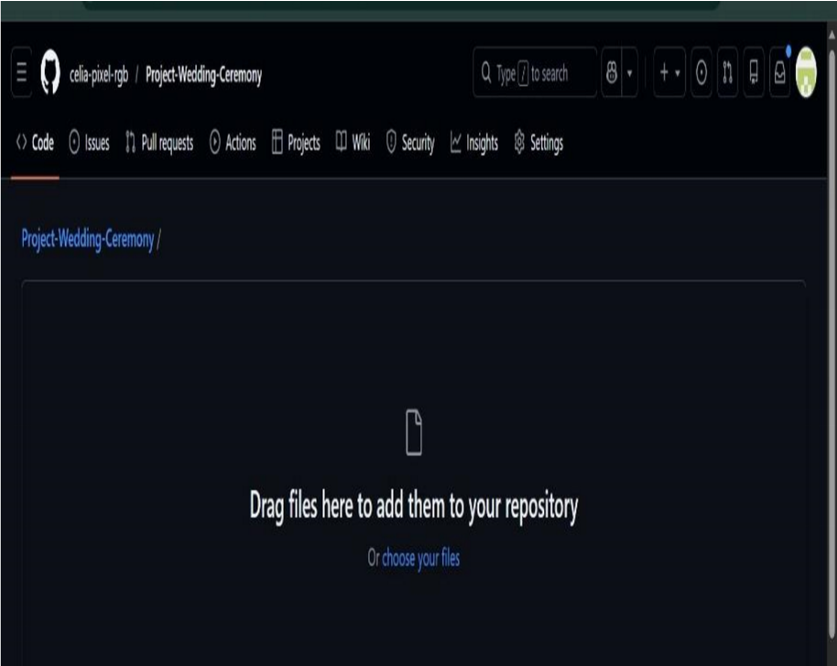

3.2Creation of the c program to manage the guests
This module manages guest information. It allow the system to:
- Create a new guest
Here, we are creating a program that can create persons (guests). Based on the wanted total number of guests entered by the user, we defined a structure in which we register guests base on their name, age, Id, social status and their side (either the bride or the groom).
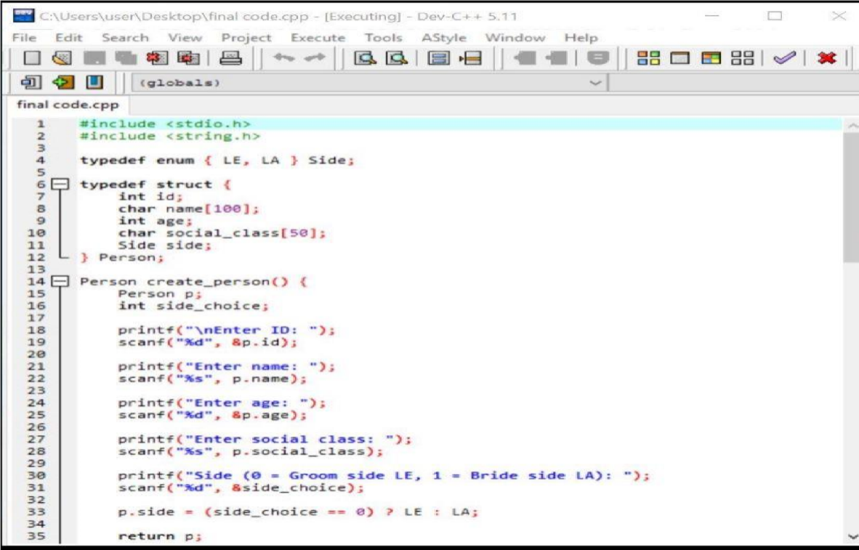
.

Display the guest
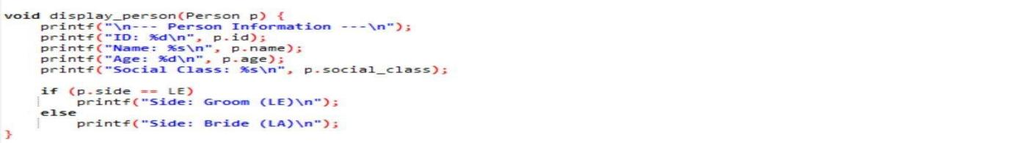
•

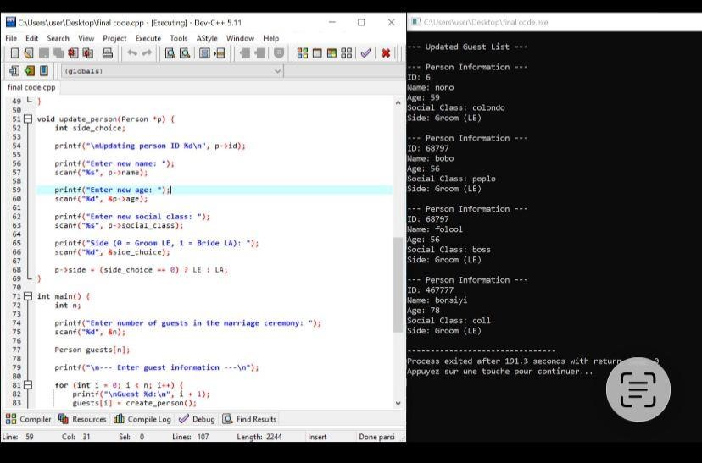
Update Guest

6. Main Difficulties Encountered
During the development of the project, several challenges were encountered:
- Understanding the use of structures in C programming
- Correctly implementing alternatives structures, loops and memory management
- Designing linked list structures for dynamic data
- Managing user input validation
- Debugging errors during program execution
These challenges required careful testing and collaboration among team members.

7.Solutions Implemented
To address the difficulties encountered, the following solutions were implemented:
- Reviewing C programming documentation and tutorials
- Testing each function independently before integration
- Using debugging techniques to identify program errors
- Collaborating through GitHub to track and fix problems
These solutions allowed the team to successfully implement the first module of the project.

8. Phase 1 Summary
The first phase of the project was successfully completed.
The team was able to:
- Understand the project requirements
- Set up the development environment
- Create the project structure
- Implement the Person Management module
- Test the system functionality
The project is now ready to proceed to the next phase, which will involve implementing additional modules that we will present later on.

9. References
The following references were used during the development of this project:
- Brian W. Kernighan & Dennis M. Ritchie – The C Programming Language
- Stephen Prata – C Programming: A Modern Approach
- ISO C Programming Documentation
- GitHub Official Documentation – https://docs.github.com
- Course materials provided by the lecturer

10.Gantt Project
This project outlines the planning, design, and implementation of a software system using structured project management techniques. The Gantt chart was used to organize tasks, timelines, and dependencies efficiently.

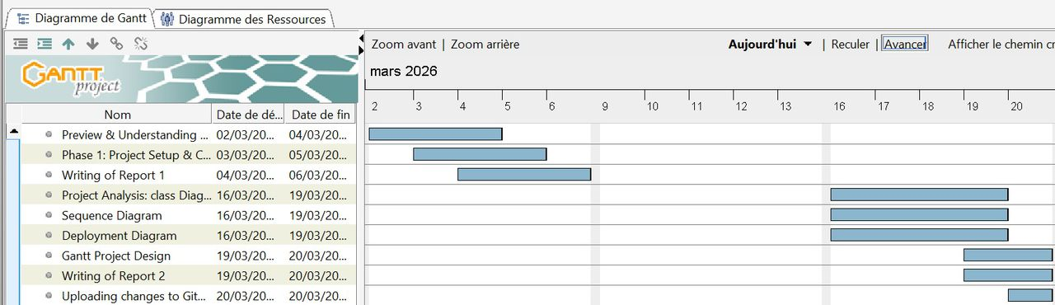
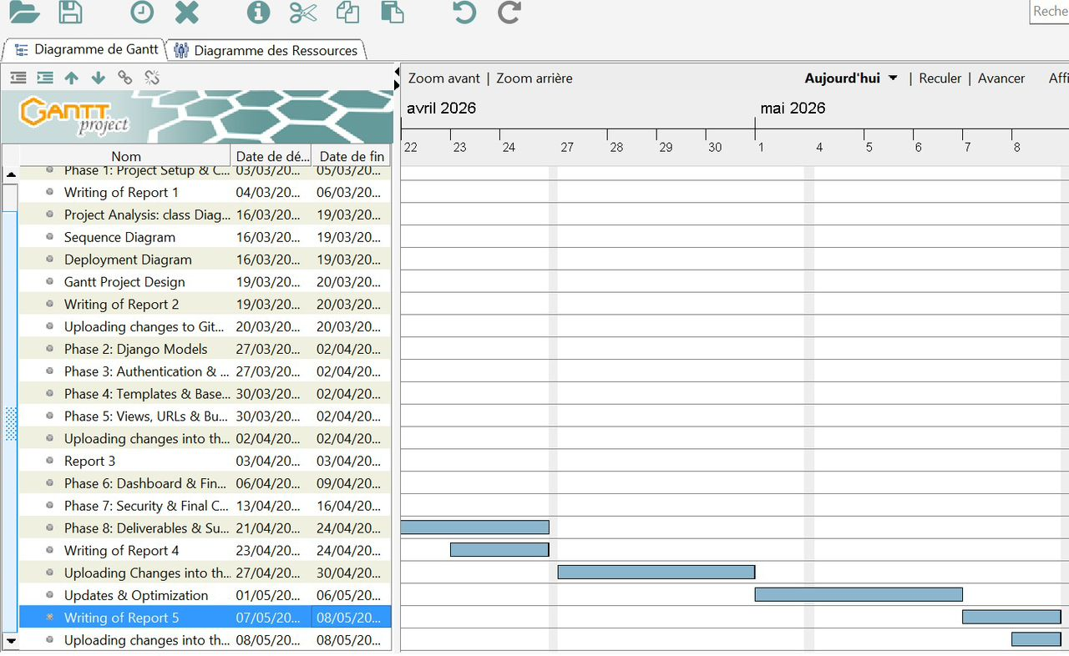
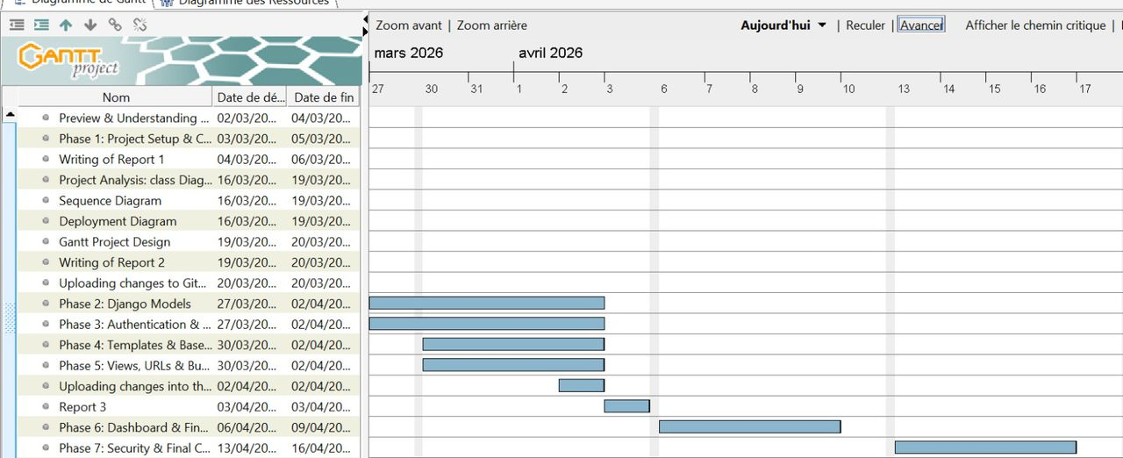

The project was successfully structured using a Gantt chart, ensuring proper time management and task coordination.
All phases were completed systematically, resulting in a functional and well-tested application.

11.SYSTEM DESIGN
System design is a critical phase in software development that defines the structure, components, and interactions of a system. It provides a clear blueprint to guide the development process and ensure that all functional and technical requirements are met.
In this section, we will present and explain the key design diagrams used in the project, including the class diagram, sequence diagram, deployment diagram, and use case diagram, to illustrate how the system operates and how its components interact.

11.1 CLASS DIAGRAM
Overview
The WIGMS UML Class Diagram models wedding organization entities using StarUML. A central Wedding class connects nine supporting classes — each with detailed attributes and defined relationships via UML associations and multiplicity notation.
- A class diagram provides a static view of the system, showing classes, attributes, operations, and relationships.
- In WIGMS, it acts as a blueprint for implementation.
- There are four classes; person, parking, gift and category
- Class Diagram
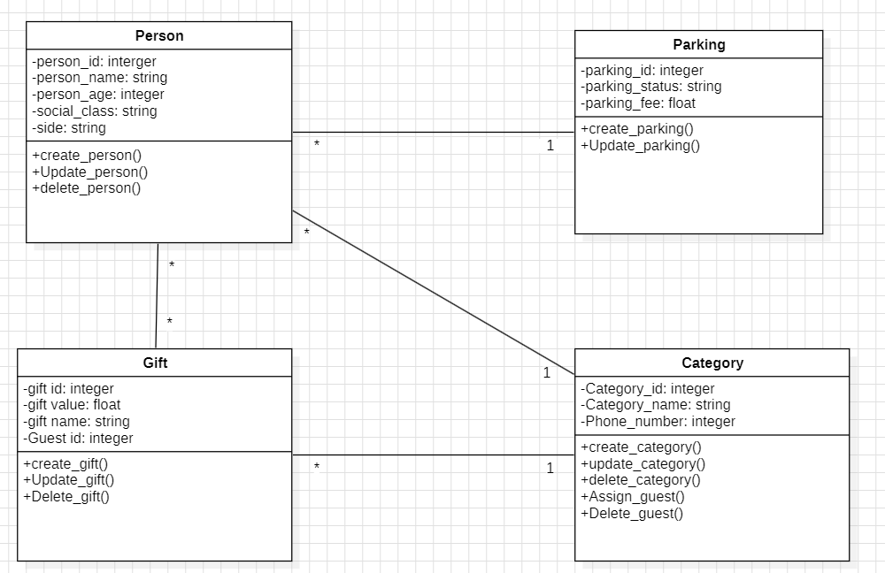

Figure 1: Class Diagram — Wedding Management System (StarUML)

Class | Attributes (private -) | Operations (public +) | Relationship
Person | id, name, age, social_class, side | create, update, delete | * → 1 Parking* → 1 Category* ↔ * Gift
Parking | id, status, fee | create, update | 1 → * Person
Gift | id, value, name, guest_id | create, update, delete | * → 1 Category* ↔ * Person
Category | id, name, phone_number | create, update, delete | 1 → * Person1 → * Gift

11.2 USE CASE DIAGRAM
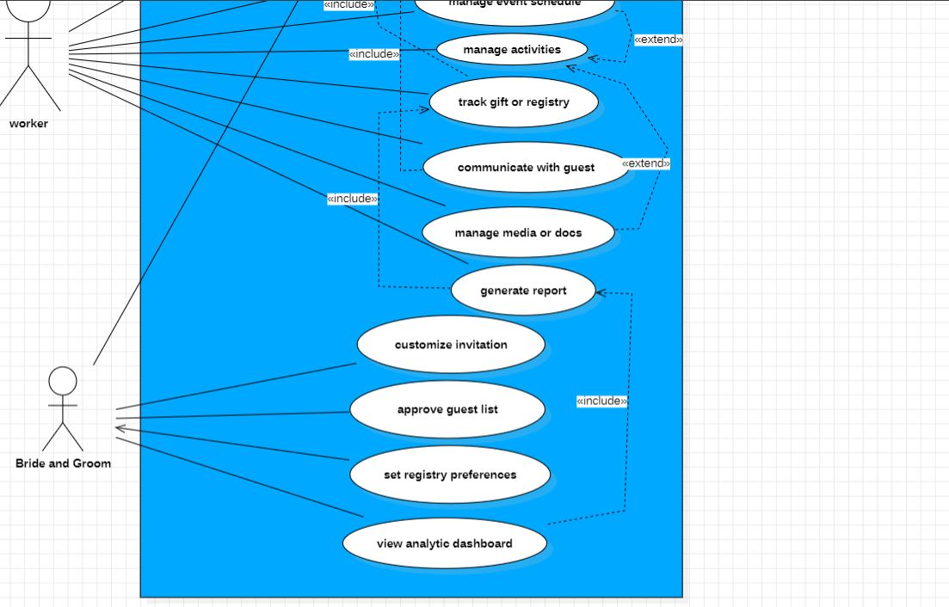
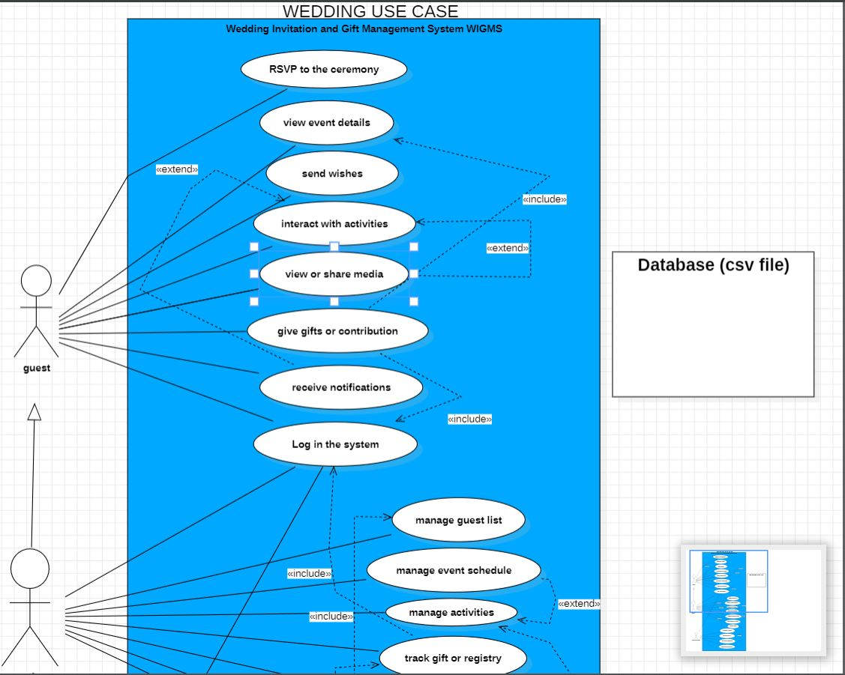
Figure 2: Usecase Diagram — Wedding Management System (StarUML)

11.3 SEQUENCE DIAGRAM

Overview
A sequence diagram illustrates how different components of the wedding-planning system interact over time through ordered message exchanges.
It helps visualize the workflow of actions such as event creation, guest invitations, and RSVP tracking, ensuring processes occur in the correct sequence.
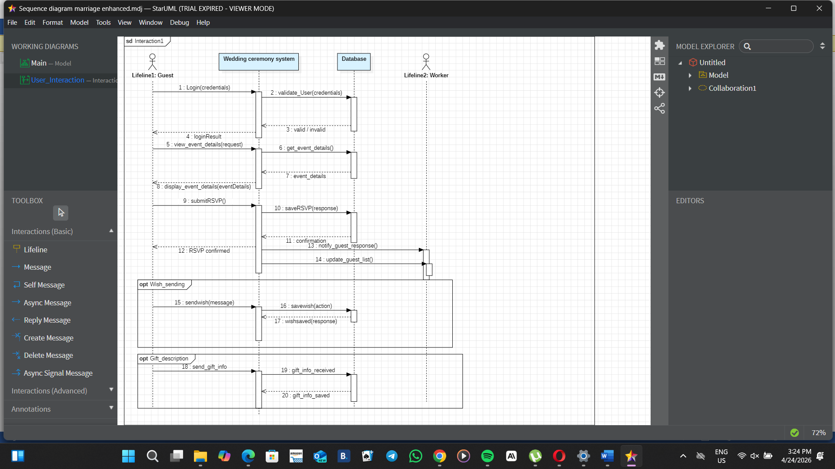
Figure 3: Sequence Diagram — Wedding Management System (StarUML)

11.4 DEPLOYMENT DIAGRAM
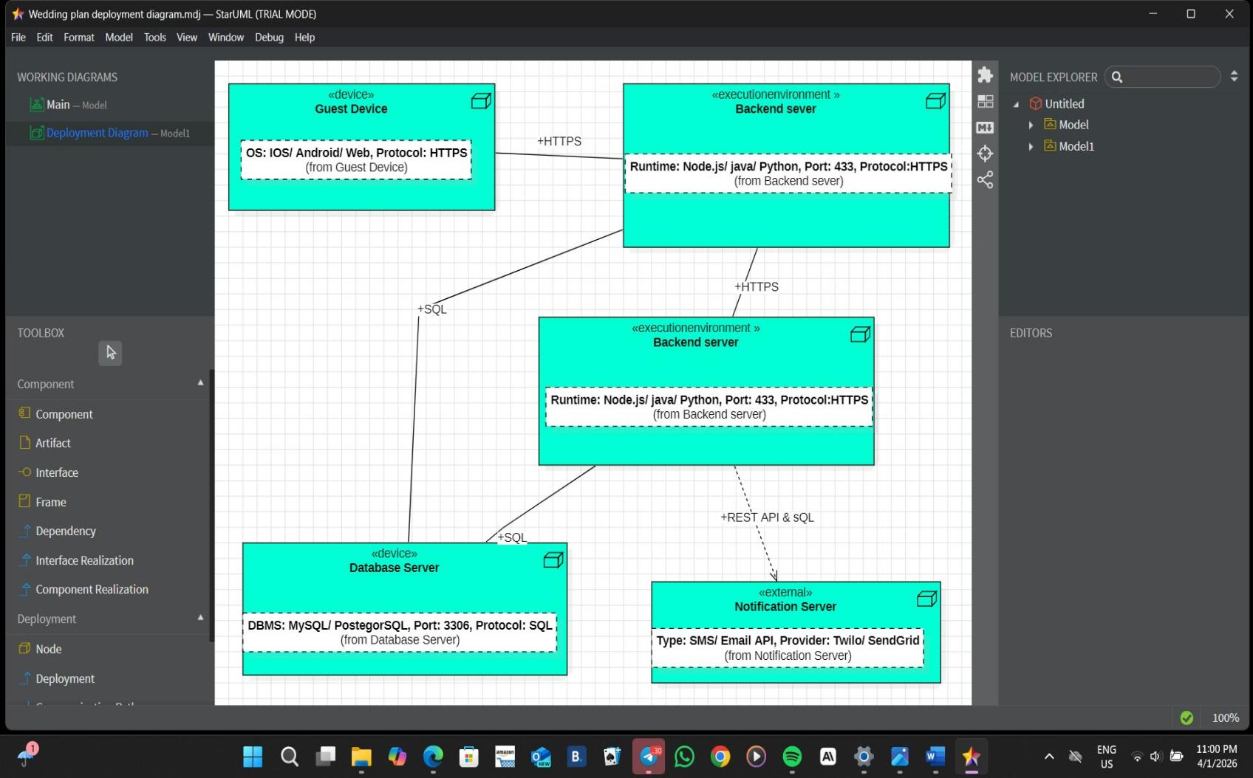
Figure 4: Deployment Diagram — Wedding Management System (StarUML)

11.5 MNEMONIC TABLE
This table will enable any person familiar with c-programming projects who may or may have not participated in the project to better understand the actions going on represented on both the use case and sequence diagrams already illustrated above.
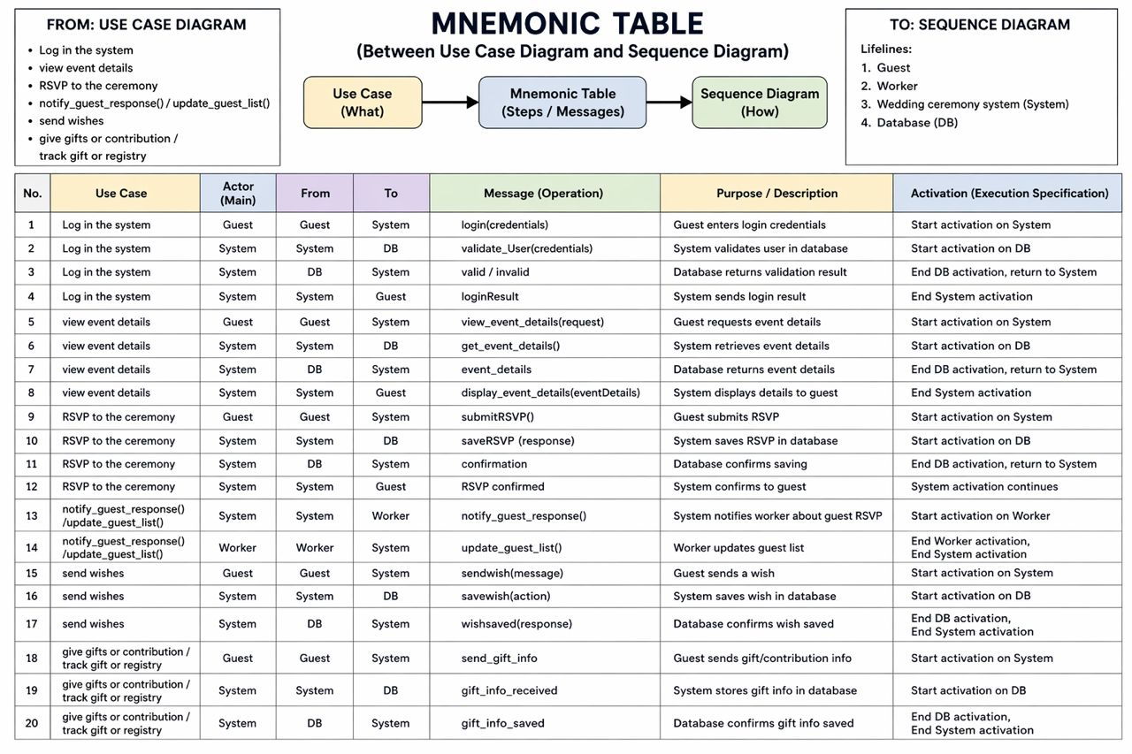

Figure 5: Mnemonic table between the usecase diagram and sequence diagram — Wedding Management System (StarUML)

12. GNU Image Manipulation ProgramToolkit (GTK) and Comma-Selected Value (CSV
12.1 GTK
Development of a GTK-based form application written in C for managing wedding guest data. The application collects user input through a graphical interface and stores it in a CSV file.
Program Overview
Download and Installation of GTK 4
The program uses GTK4 to create a graphical interface consisting of input fields for Name, Age, Status,
First, you have to download the installer at msys2.org, selecting the first version for Windows.
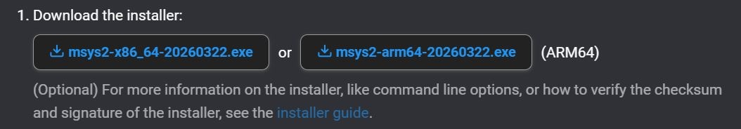

- Following this, at the end of the download process, ensure that you store the installer in a folder you will easily remember e.g wedding management ceremony.

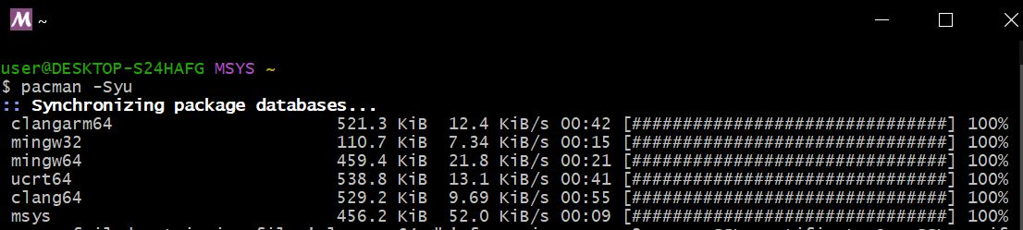
- Again, open the “MSYS2 MSYS” terminal and run the command “pacman -Syu”, and press “Y” until you finalize the installations.
- Still, run the command “$ pacman -S mingw-w64-ucrt-x86_64-gcc” into the “MSYS2 UCR64” terminal, and validate all the options till the end of the various installations.

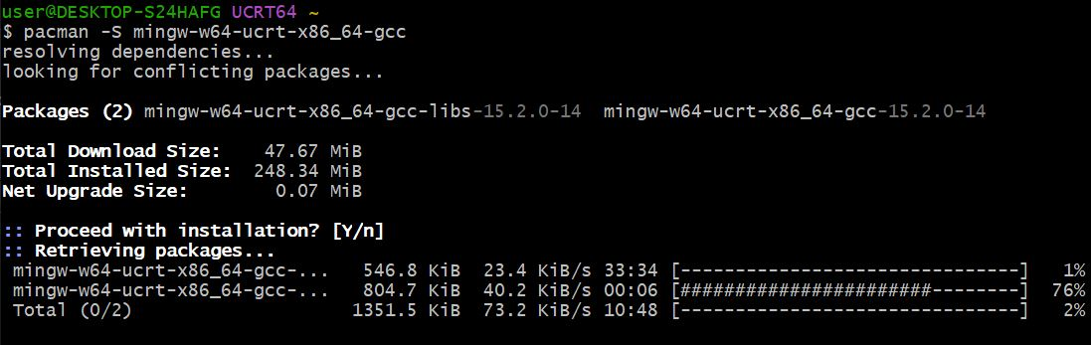
- To continue, install GTK still in the “MSYS2 MINGW64” terminal by typing the command “pacman -S mingw-w64-x86_64-gtk4”, and then install build tools by typing-in the command “pacman -S mingw-w64-x86_64-pkgconfig mingw-w64-x86_64-make” in the same terminal.

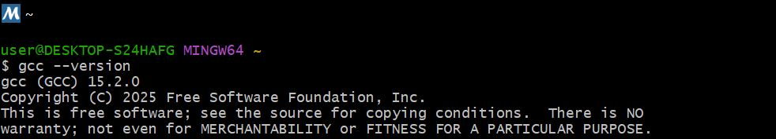
- Next, in order to ensure that the gcc compiler was well installed, run the command “gcc --version” into the “MSYS2 MINGW64” terminal. You should see the version afterwards.

- You have now installed your GTK library, you should procede further with the execution of codes.

NB
Before running a code, you must make sure that it is stored in the same folder as the one containing your GTK library files.

- If the code ran successfully, a “.exe” fileappears just below you c-code in the folder.
- In order to run the code, you must open the “MSYS UCR64” terminal ad type the command “gcc file.c -o file.exe $(pkg-config –cflags –libs gtk4)”
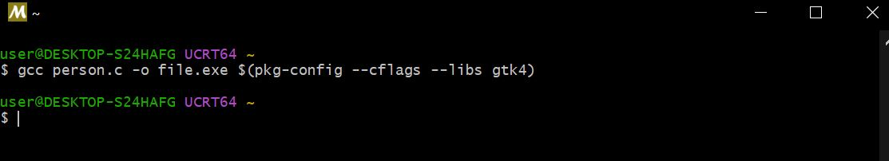

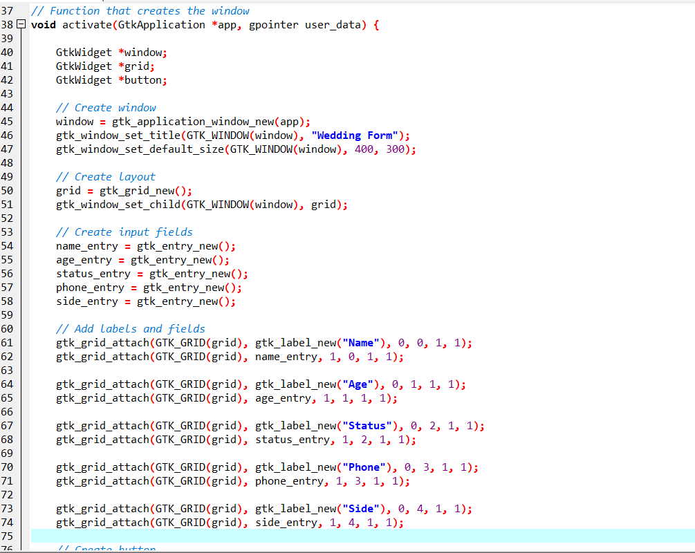
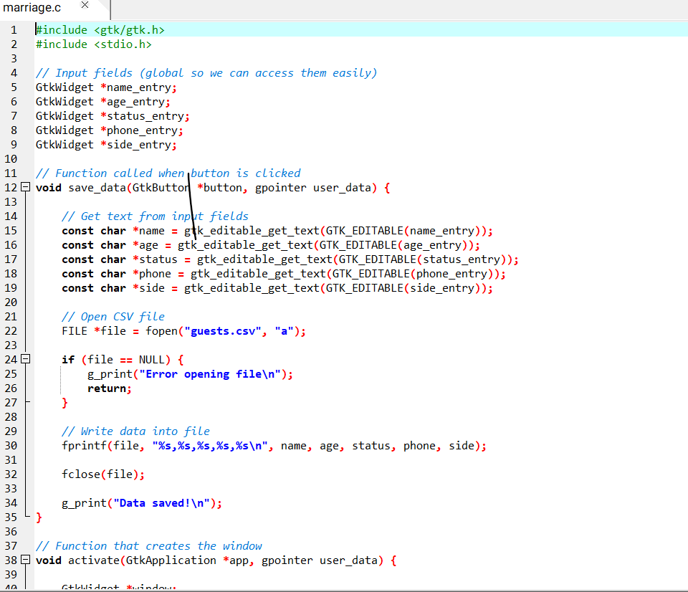
13. Key Implementation Details

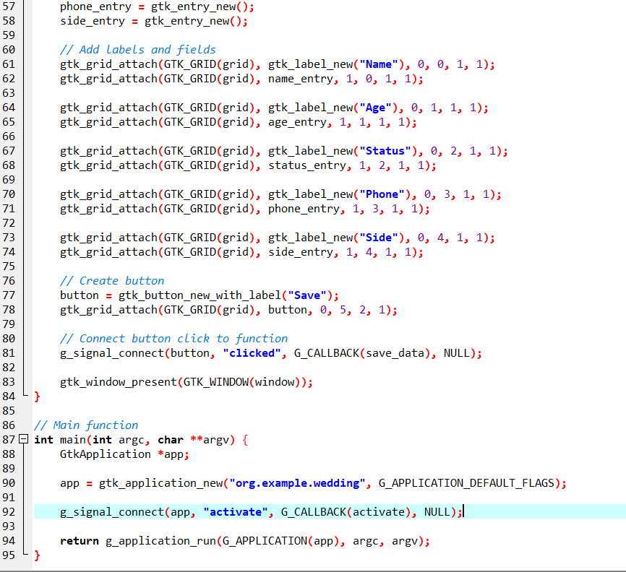

- Global widget pointers were used to allow access to input fields across functions. This simplifies retrieving user input when the Save button is clicked.
- The use of gtk_editable_get_text() allows extraction of user input from each entry field. This is required because GTK widgets do not directly expose their content.
- File handling is implemented using fopen in append mode ("a").
This ensures that new data is added without overwriting existing entries.
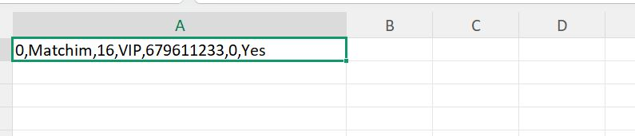
12.2 Csv file creation

The csv file was generated immediately after the GTK form worked, and was tested by inputing arbitrary entries

    - Problem Encountered and Solution

General Problem
- Difficulty in configuring development tools such as GTK.
- Limited understanding of UML diagrams (sequence, deployment, use case, class).
- Challenges in using StarUML (navigation, relationships, layout).
- Errors in coding such as file handling, compilation, and signal connections.
- Complexity in organizing system interactions and component communication.

12.2.2 General Solution
- Proper installation and configuration of development tools.
- Studying UML concepts and applying correct diagram rules.
- Practicing and exploring StarUML features for better usage.
- Applying debugging techniques and correct coding practices.
- Breaking the project into smaller tasks using structured planning tools like Gantt charts.
    - Conclusion
The Wedding Ceremony Management System demonstrates how C programming can be combined with project planning tools, system design diagrams, and user interface technologies. The use of GTK and CSV enhances usability and data management, making the system efficient and practical for real-world applications.

13. PERSON AND CATEGORY MANAGEMENT: IMPLEMENTATIONS & TESTS
13.1 Person Management
This module concerns the registration of the guests at a wedding ceremony, alongside all the operations carried out on them (Entry, Update, Delete). The previous model in the second report being lacking, the following is an update version
- The c-program was written and thoroughly debugged using dev c++ software

13.1.1Extract of Person Management C-code

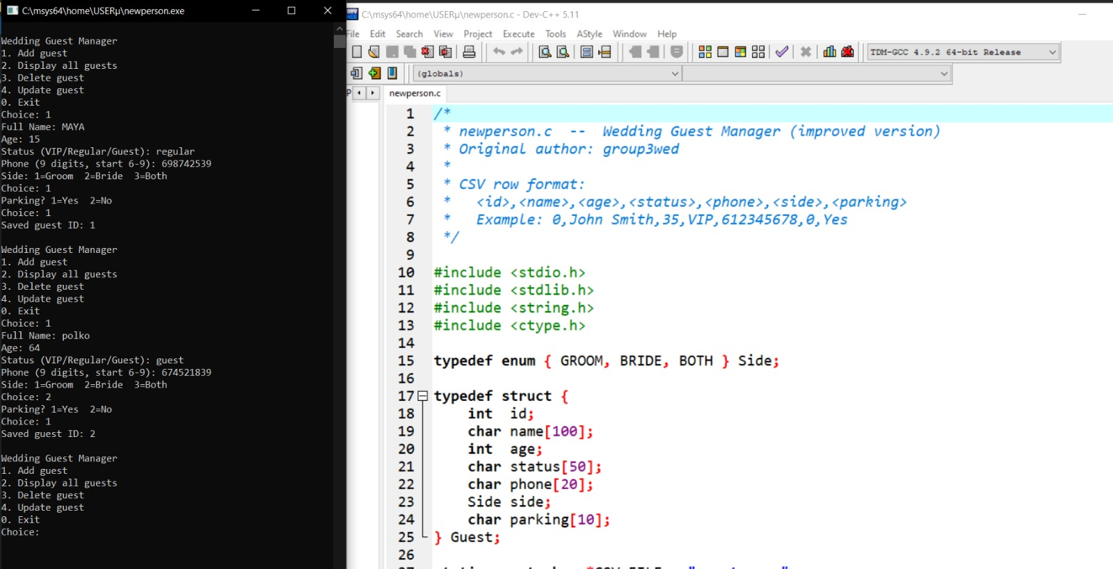

- Once written, the c-program was converted into a GTK form using GTK-specific libraries

Extract of person management GTK c-code
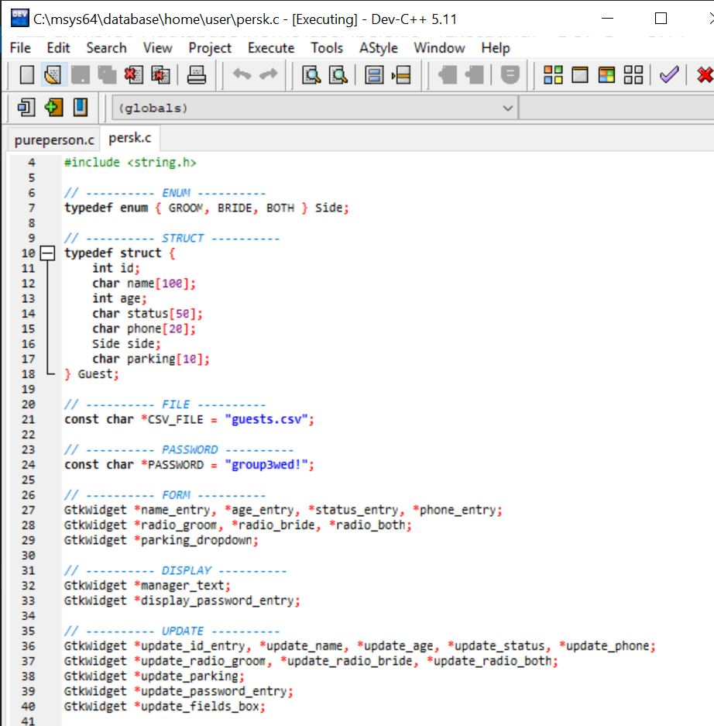

- The csv file was automatically generated below the gtk person management file immediately the gtk compiled successfully.

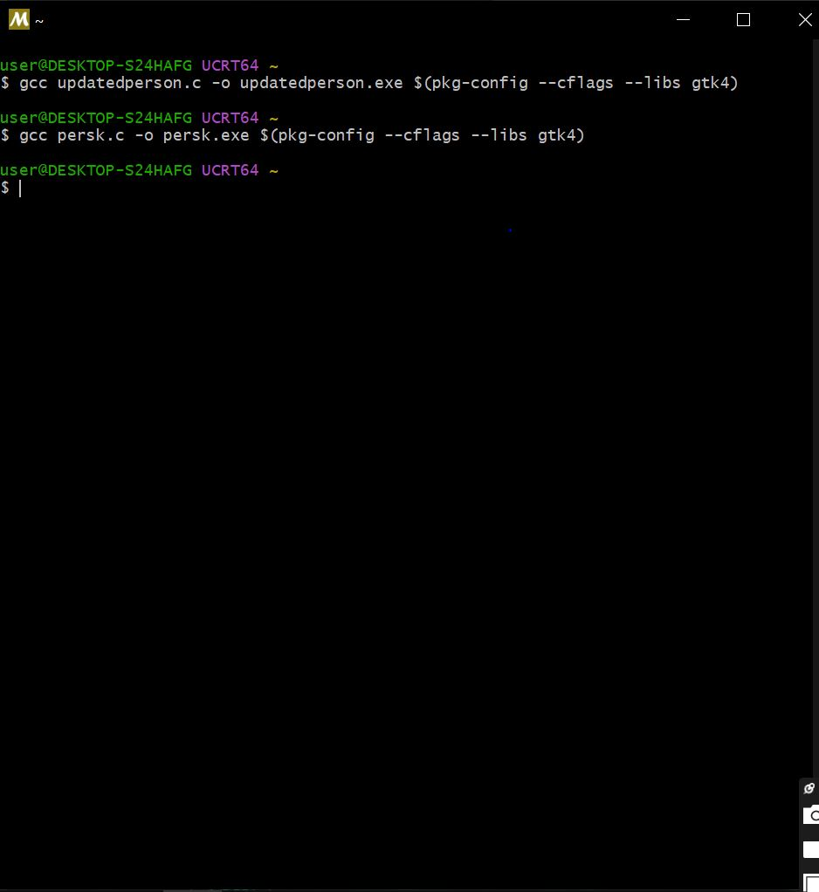
GTK ran successfully

executable

- Tests were carried out to verify that the Person management form performs its job correctly

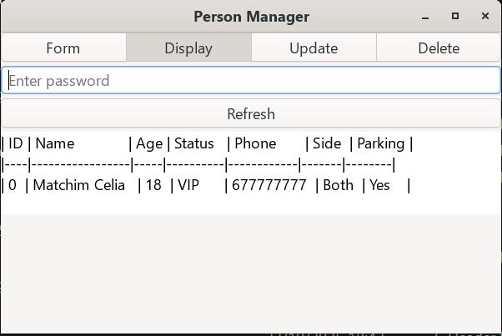
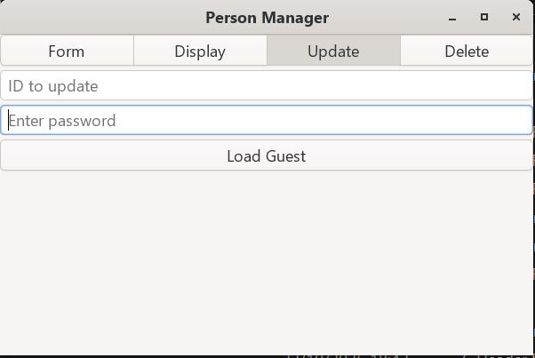
  - Person registration (b) Person update

13.2 Category Management
The category management module was implemented in order to allow for creation of different categories at a wedding ceremony.
-Just like the person management module, alongside all the operations (Display, Update, Delete, Assign Guests)
- For assigning guests, the code was linked to the person management code, through the ID
- The code was thoroughly debugged using dev c++ software

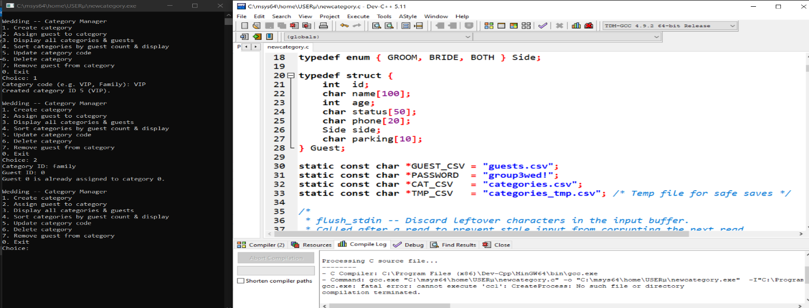
Extract of Category Management C-code
- Once the category management c program was correctly implemented, the GTK form version was created.

Extract of Category Management GTK code
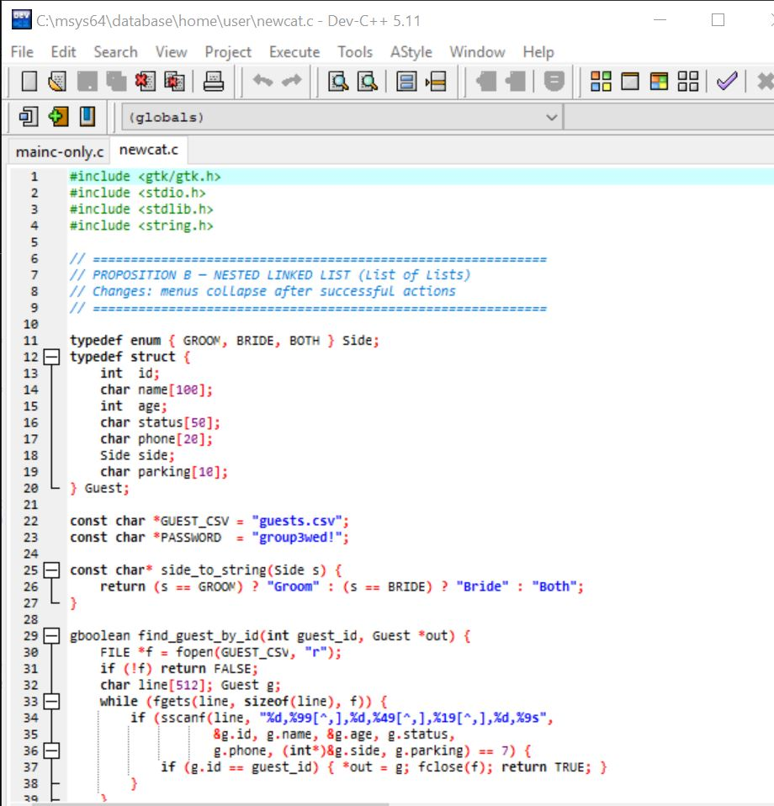

- Haven properly run the code, the csv file was created automatically below the category management.

Category ran successfully
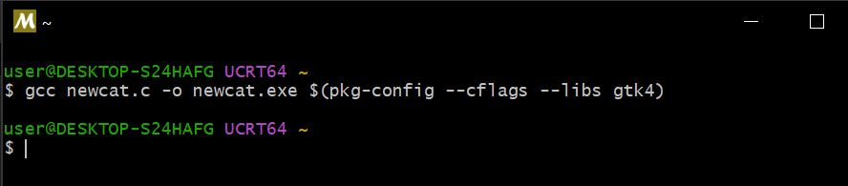

Executable file

- Haven properly created the csv file, test were carried out, similarly to those in the person management, to ensure functionability

Category Manager Window
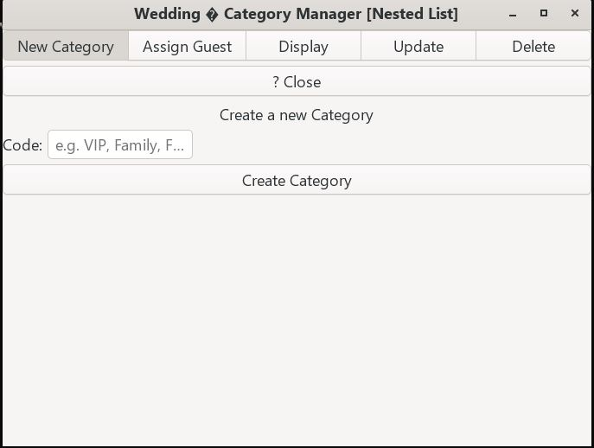

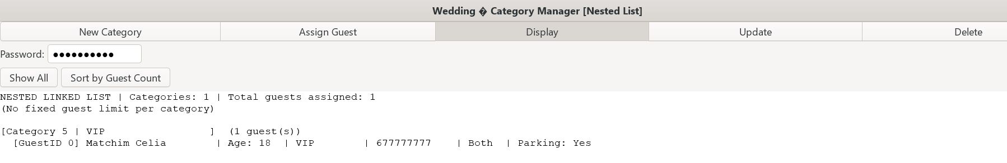
Assignment Page

14. COMBINATION OF PERSON AND CATEGORY MANAGEMENT ONTO A SINGLE WINDOW
Haven made the person and category management fully-functional; it is necessary to combine them in a single window where a user has the possibility of choosing which to fill.
- The c-code, mainapp, was written, thoroughly de bugged and converted to a GTK form, and the csv file generated subsequently

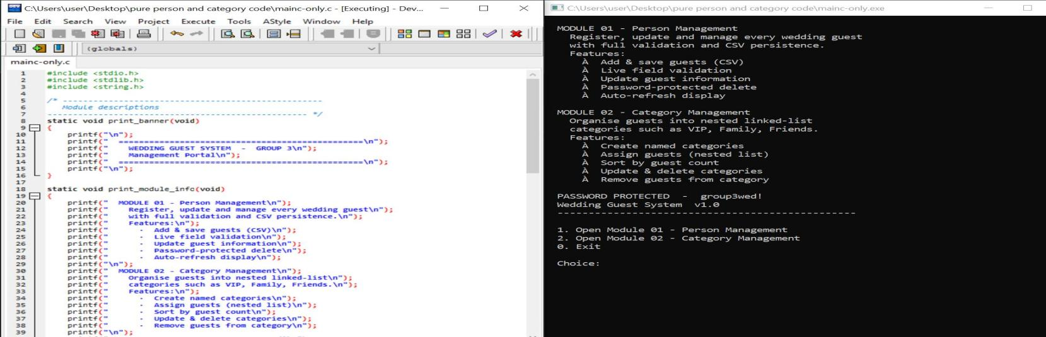
Main code with c only

- Css was added to the GTK inorder to beautify the window

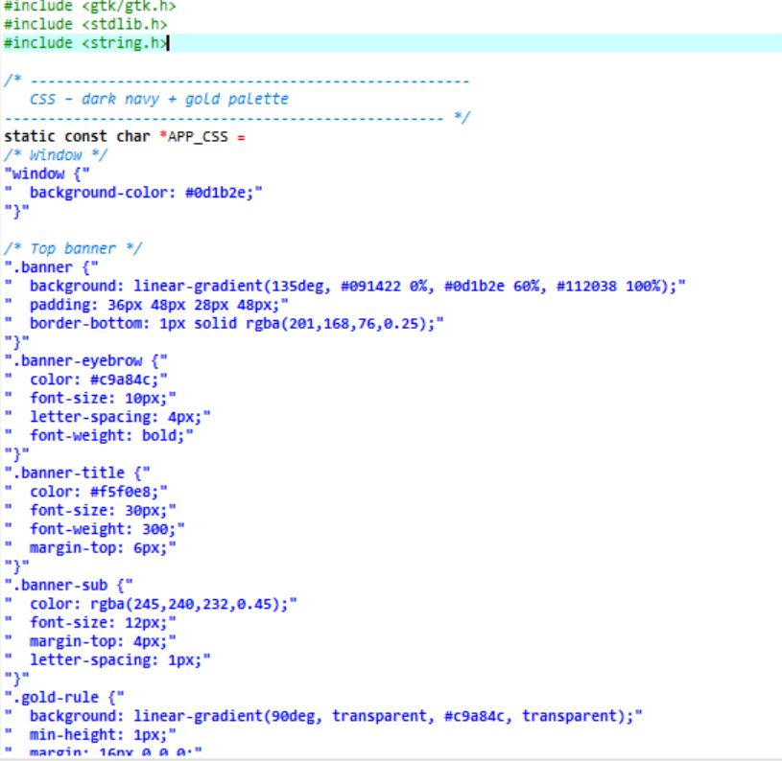
Extract of Main code with Css

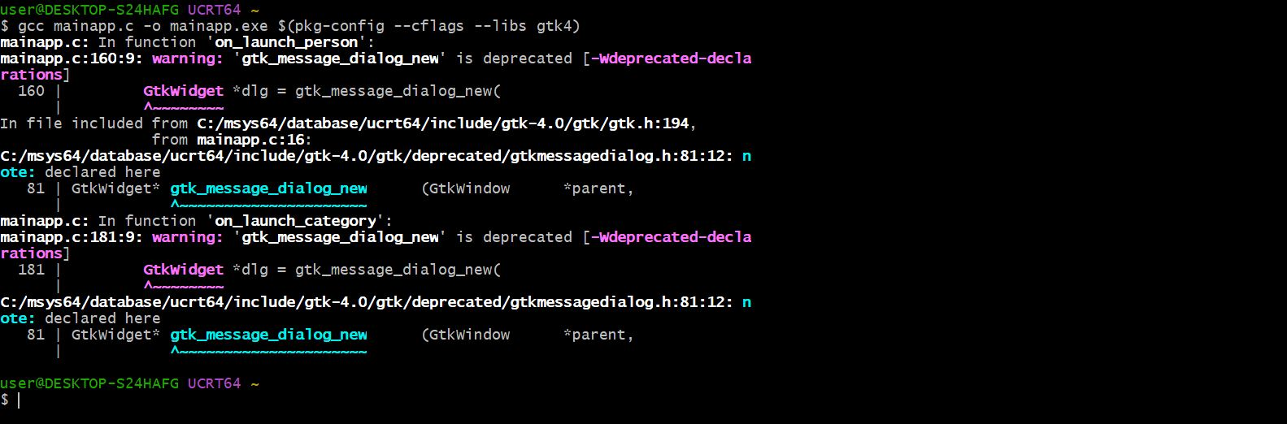
mainapp ran Successfully

Executable file

Main Window
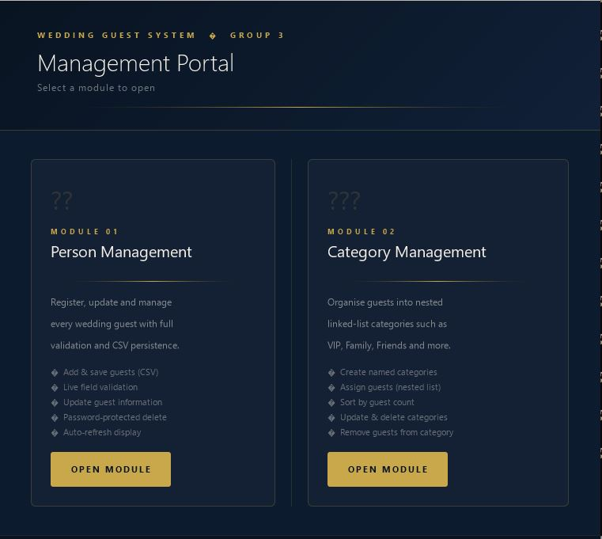

NB:
- A password was used to prevent guests from accessing fields other than registration. Password: group3wed!
-For being lengthy, full codes could not be integrated in our report. Full codes are available in the GitHub repository at this link: https://github.com/celia-pixel-rgb/Project-Wedding-Ceremony
- All the outputs of the codes are present in the repository too.

16. CONCLUSION
With Modules 1 and 2 implemented and optimized, we are ready for the implementation of modules 3 and 4.

